**Assessing the Validity of Online Information**

**Keep in mind:**

* No internet quality control
* Practically anyone can publish a home page or web site
* Contributors to such a site have a level of anonymity
* Potential for great irresponsibility
* Easy to access web site in which persons with unclear qualifications seem to speak with authority on complex topics, about which they may in truth have no real knowledge or expertise

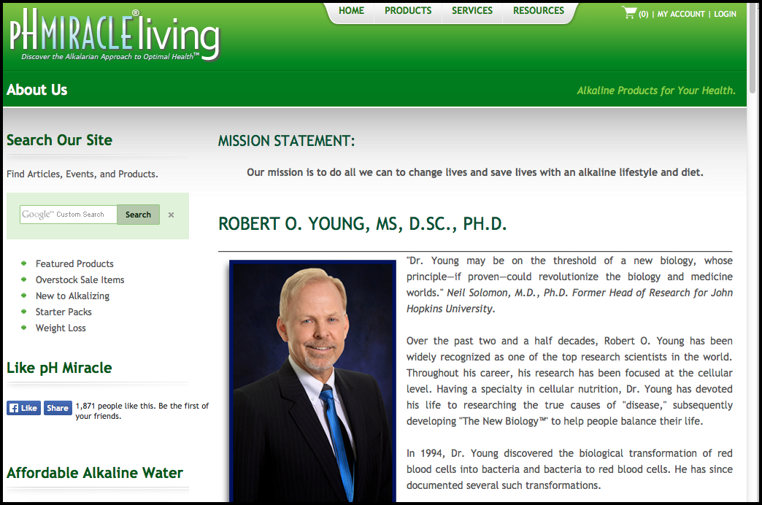

**Example #1: www.phmiracleliving.com** http://www.phmiracleliving.com/default.aspx http://www.phmiracleliving.com/default.aspx **http://www.phmiracleliving.com/default.aspx http://www.phmiracleliving.com/t-about.aspx** **http://www.phmiracleliving.com/t-about.aspx**

**What questions does this site raise?**

**Possible questions:**

* Authors Credentials?
  + Education
  + Current affiliations
  + Work experience
* Are they trying to sell something?
* Are claims substantiated?
* Has the author had any criminal charges brought against him/her?
* Links to other credible sites? Credible sites linked to him/her?
* What kind of contact information is provided?
* Is this site sponsored by a known entity?
* Is this information credible?

**Determining a Site’s Trustworthiness**

Validity Currency Content Purpose Accuracy

**Validity**

### Who is/are the author(s) of the site? What are their credentials?

### Always check credentials through another source (paper or Web)

### Contact Information

### Is contact information provided?

### You can reach the author by phone or mailing address?

### Does author have her/his own page and is there a link to that page?

### Examining the Website URL or address

### For example: http://www.nih.gov/news

Hyper Text Transfer Protocol

### Directory Path

Domain

World Wide Web

Server or Website (in this case the National Institute of Health)

### The Domain is usually (but not always) descriptive of what type of entity hosts the website. These endings (except .gov & .edu ) can be purchased by anyone and used on any kind of site.

Some common domains issued by ICANN (*Internet Corporation for Assigned Names and Numbers)* include:

### .edu - educational institution (entity must qualify to use this domain)



### .net - network provider -provides services to customers

### .gov - government agency (entity must qualify to use this domain)

### .org - non-profit organization (may be biased)

### .com - commercial enterprise (usually trying to sell or endorse products)

**Currency (and other information of record)**

Check the date the site was first published and the most recent update(s)

* + - [Whois.com](http://www.whois.com) or [networksolutions.com/whois](http://www.networksolutions.com/whois) 
      * Provides information about the site, date registered, owner, etc.
      * Contains all of the contact information associated with the person, group, or company that registers a particular domain name

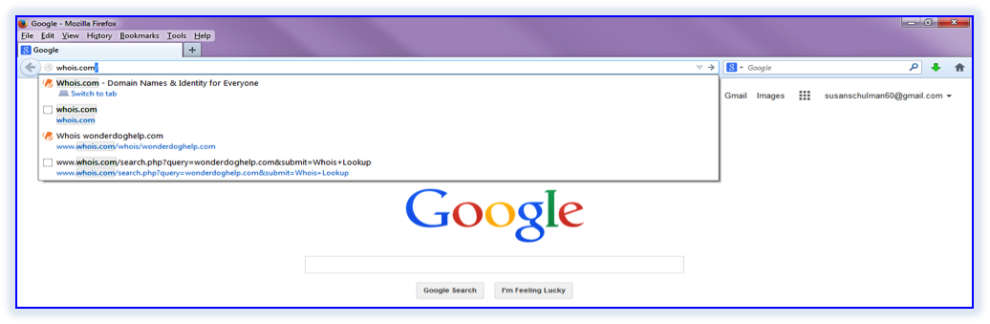

Type: [whois.com](http://www.whois.com) in the address bar

Lots of good

information!

Type in Website that you want to look up

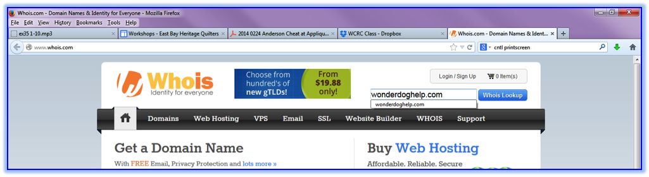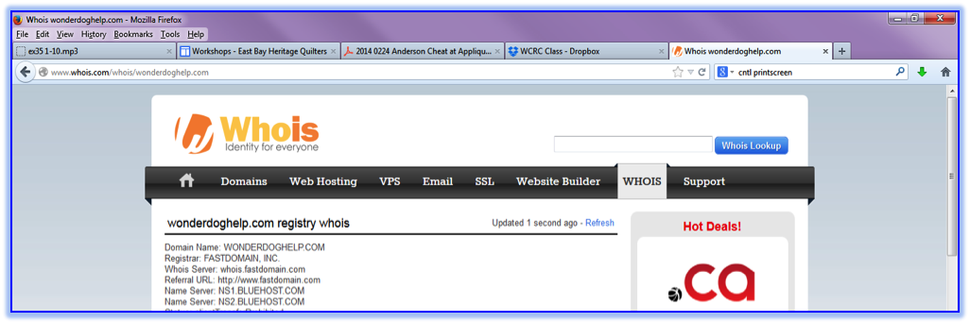

**Content**

* What is the depth and breadth of the information offered?
* Are there links to other useful and reliable sites?
* Are other sites linking to the one you are viewing?
  + Go to Google (or other Search Engine) & in the search field type:
    - “link:[name of your website]” no space after the colon.
    - The resulting search will contain **websites that link** to your site.

Type your search here

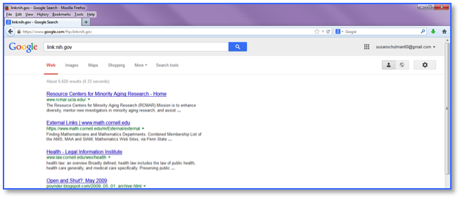

**Purpose**

What is the main purpose of the site?

Why did the author write it and the publisher post it?

1. To sell a product?
2. As a personal hobby?
3. As a public service?
4. To further scholarship on a topic?
5. To provide general information on a topic?
6. To persuade you of a particular point of view?

Scan the homepage of the website.

* + - Is it cluttered with advertising?
    - Does the page appear to be professionally designed?
    - Is the writing trying to persuade you to buy something?
    - Who is the intended audience?
      * Scholars, Scientists or the general public?
      * Which age group is it written for?
      * Members of a particular profession or with specific training?

Bias

* Sites with a political ax to grind
* Look for sites that are non-partisan and unbiased.
* Learn to read for bias, political, gender, religious, racial or other.
* Even non-profit (.org) sites can have a bias.
* Recognize a source that doesn’t give the whole truth.
* Are there advertisements on the page?

Commercial Sites

* Websites usually end in .com
* Most are selling something.

Relevant topics

* Topics discussed should be relevant to what that website is about.
* The aims of the website should be clear.

**Accuracy**

Information given on the site must be credible and error free.

References

* + In a research article, is the source of information clearly identified?
  + Does article explain research methods used to gather and interpret data?
  + Does the document contain any broken links?
  + If the document quotes or refers to other sources, does it include a bibliography or link to the original source documents mentioned?
  + Is there a way to verify any background information provided in the document?

Are there references & links that reflect the quality & amount of research put into work.

What is the organization’s main purpose?

* Educational?
* Commercial?

Is this a reputable organization?

Check the organization’s main website, if this is an article on a bigger website.

**From Example #1, Page 1:** [**www.phmiracleliving.com**](http://www.phmiracleliving.com)

1. Try Searching on the following terms: Robert O. Young legal action against
2. Look Dr. Young up in [Wikipedia](http://www.wikipedia.org)
3. Checkout [www.quackwatch.com](http://www.quackwatch.com) (a website dedicated to combating health related fraud)
4. Use [iMedisearch](http://www.imedisearch.com/) for medical related queries (a customized Google engine specifically built to search medical-related resources)

***A little bit of research into Robert O. Young will reveal the following:***

* Despite claims of being “widely recognized as one of the top research scientists in the world”, Dr. Young has never published in a peer reviewed medical journal
* Dr. Young trained under the “respected” Dr. Robert Bradford at the Bradford Research Institute in Chula Vista. However, Robert Bradford was convicted of laetrile smuggling in the 1970s, and was not a college graduate at the time of his “mentorship”
* Dr. Young’s two doctoral degrees were both obtained from schools widely known to be “credential mills”
* There is no evidence that his Research Institute has ever actually conducted any research
* In 2009, [Young claimed that he had cured Kim Tinkham](http://www.skepdic.com/graphics/youngkimbig.png), a woman with breast cancer who had appeared on the Oprah Winfrey show. He also posted six testimonial videos to his Ph Miracle Living site. However, Tinkham died of her disease about a year later
* Young has been prosecuted 3 times over the course of his career on felony charges
* In January 2014, Young was again arrested for conspiring to practice medicine without a license and multiple counts of grand theft
* Dr. Young is currently being investigated by the Medical Board of California and the FDA Office of Criminal Investigations.

**Example #2 A Quick Look at Email**

**This email promises an all-natural method for lowering blood pressure. Could it be true??**

**Step 1: First examine the email carefully. Note the 5 points listed below**

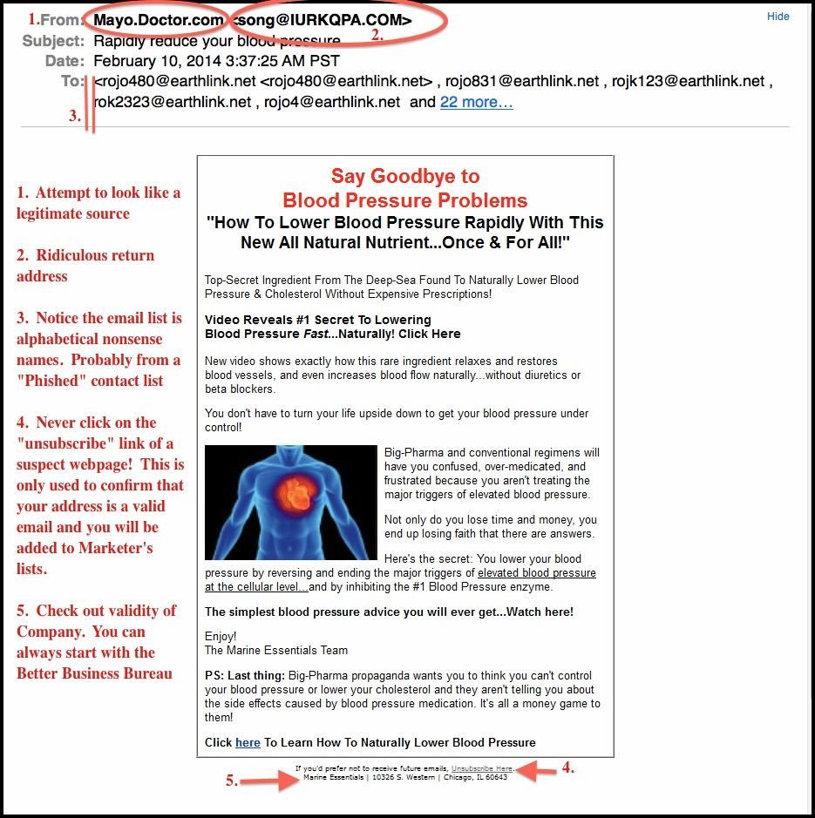

**Step 2: Look the Company Up on the BBB, then google the company**

**Step3: Pat yourself on the back for avoiding a scam!**

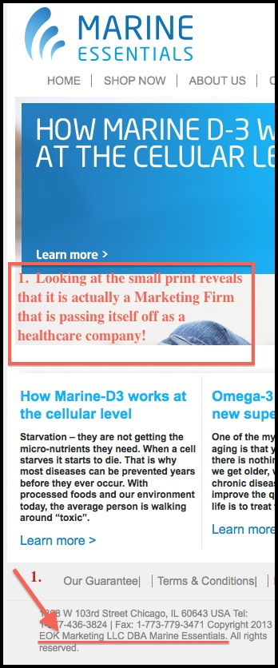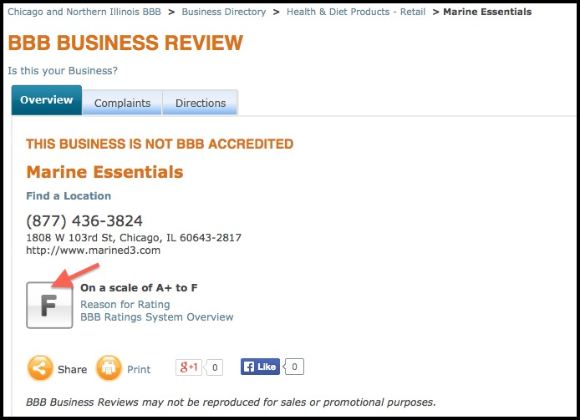

 

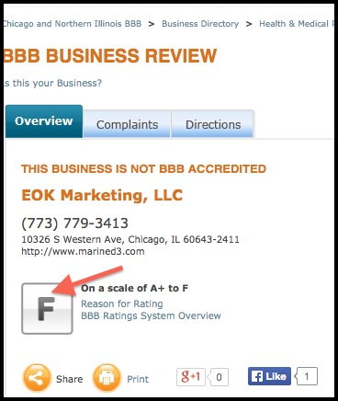

And finally, if we look at the BBB rating for this Marketing Company (EOK), we see that they, too, have an ‘F’ rating

**Examples of sources that are often the most credible:**

1. Official government websites
2. Institutional sites that represent universities, regulatory agencies, governing bodies, and respected organizations with specific expertise (e.g., the Mayo Clinic)
3. Peer-reviewed journals
4. Reputable news sources

**Examples of sources that are often considered less credible:**

1. Blogs
2. Web forums
3. Individual or business websites
4. Materials published by an entity that may have an ulterior motive

**Try these sites to begin your research:**

<http://scholar.google.com>

contains citations to journal articles and other publications, with links to publishers or other sources where one can try to access the full text of the items

<http://www.ipl.org>

Internet Public Library (IPL) and the Librarians' Internet Index (LII) websites. The site is hosted by The College of Computing & Informatics at Drexel University. A [consortium of colleges and universities](http://www.ipl.org/div/about/IPLconsortium/consortiumList.html) are involved in developing and maintaining the ipl2.

<http://infomine.ucr.edu>

INFOMINE is a virtual library of Internet resources relevant to faculty, students, and research staff at the university level. It references databases, electronic journals, electronic books, bulletin boards, mailing lists, online library card catalogs, articles, directories of researchers, and many other types of information.

<http://newstrust.net/sources>

NewsTrust.net provides a wide range of tools that enable users to separate fact from fiction on important public issues. Its mission is to promote good journalism, news literacy and civic engagement.

<http://www.jstor.org>

A great database of scholarly articles. Enter a topic into the search bar, and JSTOR searches thousands of peer-reviewed journal articles for information.