TOPIC I: Managing your files

1. Storing Information

a. Files

i. What is a file
ii.What can be in a file

A letter
A book
A list of groceries
A photo
A spread sheet
Part of a database
System files
Windows files
Any picture or written material

- Folders

    - What is a folder
    - What can be in a folder

ONLY files or other folders

2. Making a new folder

  - Open Windows Explorer (see #4 below)
  - Select the folder in which you want the new folder to be
  - Click on File -> New -> Folder
  - Type the name of the folder

3. Save vs Save As (for documents, pictures, spread sheets, and more)

      - Save As command – A dialog box will open to ask you where you want to save the work you have
done. You are creating a new file to hold this document, spread sheet or picture.

- ‘Save in’ box is asking which folder do you want to save it in
  - Use the drop down menu.
  - Click on the folder you want to save your work in.

- ‘File name’ box is asking what you want to call this new file you are creating.
  - Type in any name that you want to call it.

- Save as type box: usually filled in correctly for you – don’t change it.

- Click on save.
Save in:

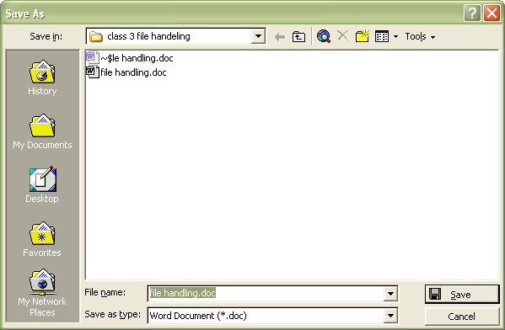

File Name

Save As Type

      - Save command - saves the changes you have made in the same place you opened it from.
- The program (Word, etc) doesn’t ask where to save. It will automatically save in open file.
- BIG EXCEPTION – for a new document the Save as box will display. (see above)
4. Windows explorer
a. Getting to Windows Explorer
- Click on my Computer (on your desktop)
- Click on Folders (on toolbar under the menu bar) unless the list of folders is already showing.
- Click on My Documents (in the left box)

b. Looking at Windows Explorer
- Desktop
- My Documents
- My computer
- plus (+) and minus (-) signs: plus means there are other folders inside this folder

Fig 4.1 – This is a picture of windows explorer showing all of the My Music folders and files in the right pane. Notice that My Music is selected in the left pane. Select by just clicking on the folder.
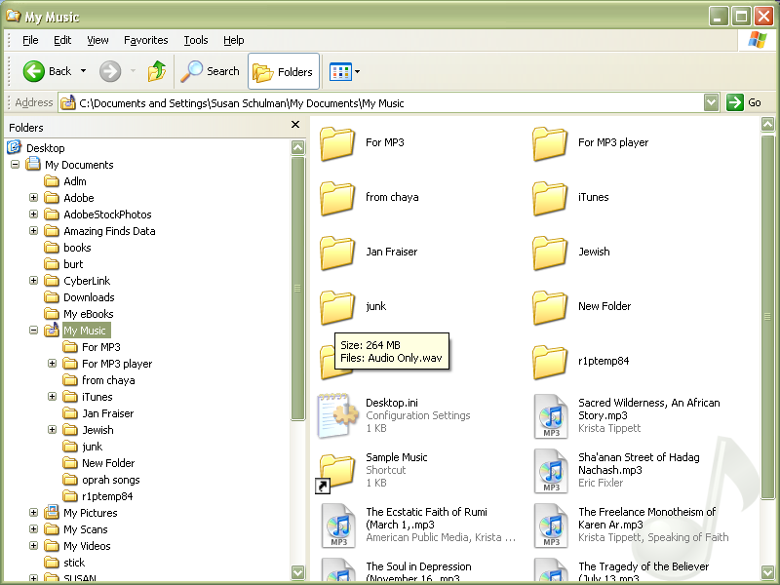

Right Pane

My Music

Left Pane

5. Copying (or moving) files and/or folders to another folder

  - Copy Vs. Move
  - How To Copy (or move) a File or Folder into another Folder in Windows Explorer
    - Right Click on the file or folder you wish to copy (or cut if you want to move it).
    - Click on copy
    - Reposition the cursor in the left pane and right click on the folder you want to hold the copied file or folder
    - Click on paste

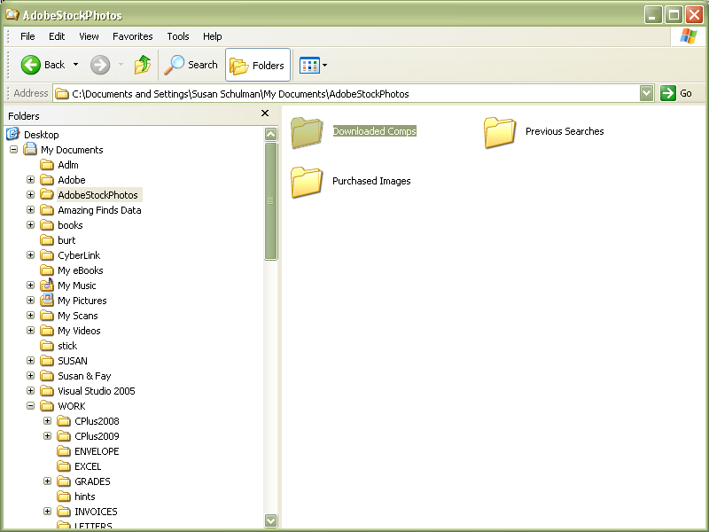
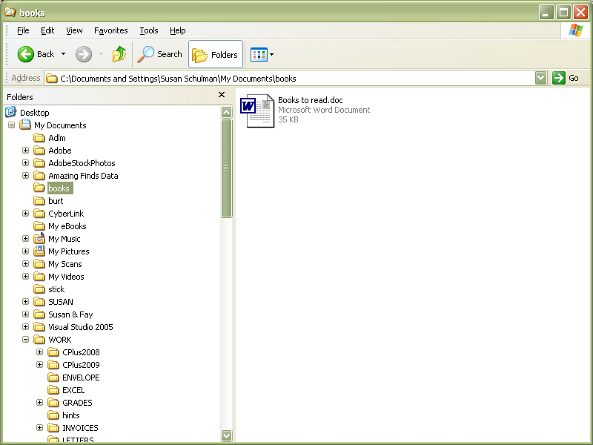
undo

cut
copy
paste
delete
undo

cut
copy
paste
delete

Results of right click on Download Comps

Results of right click on Books

6. Find Your Files --- Use The Search Magnifying Glass

a. Go to Start Menu in lower left corner of your screen
b. Click on the magnifier or the word “search”
c. Fill in the form, as shown below

6.1. Narrow your search results

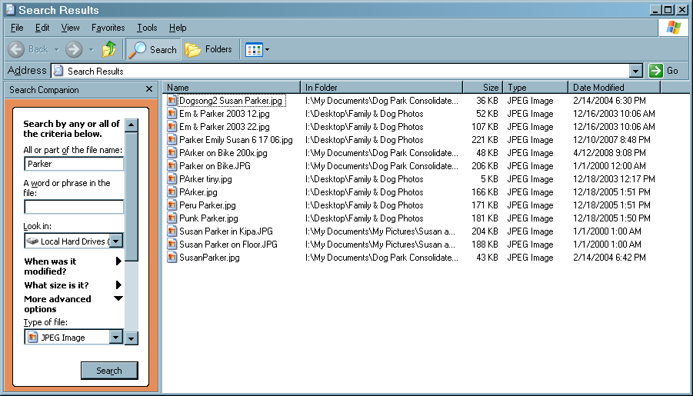

6.1 - Too many results in your search?

  - Narrow the search to find just one file type as in Fig 6.1 above
  - Fig 6.1 shows the file type of JPEG (which is a picture). Search finds only files of file type JPEG.
  - The results show in alphabetical order.

6.2 Look at the screen below for a different order

- Click on View on the menu bar
- Click on Arrange Icons By
- Click on the way you want the icons sorted (name, type, date etc)

6.3 And different way to display.

- Click on View on the menu bar
- Click on the view you want to display the results (tiles, list etc)

6.2 Show results in a different format (EM: we need another pic here of the icons arranged in date order in a detailed list so that we can write that it is in date order in a detailed list cause I don’t know what order this is)

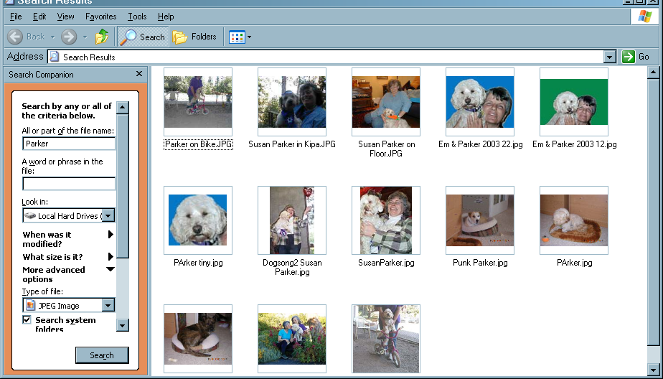

6.4 Search for information within a file
Here I want to find somebody named Susan who made a quilt square for Sarah.

a. Enter the word Susan in the box for “word or phrase in the file”
b. Enter the time period and click on Search
c. Note that I decided to display the results as icons this time. (see 6.3 above)
d. I click on file I think most likely to have the information I want

Figure 6.4
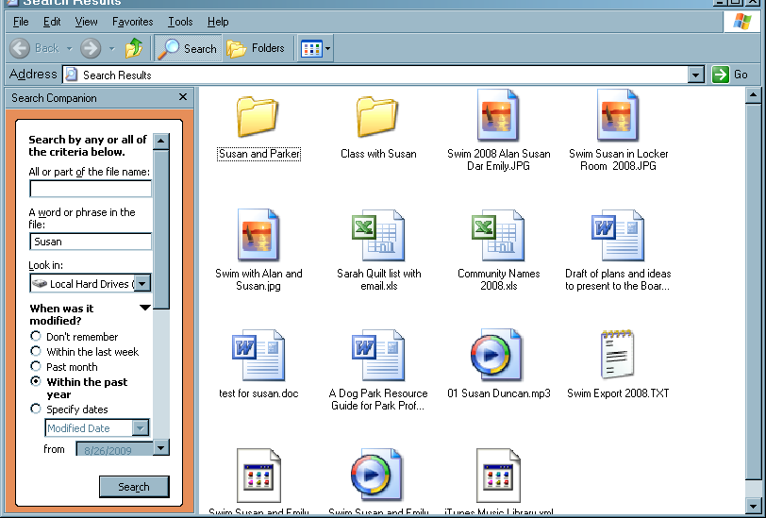

7. Set up the headings most useful to you in the detail view

a. Click on View on the menu bar
b. Click on Choose Details
c. Click on the boxes with the details that you want to show

8.1 choosing details
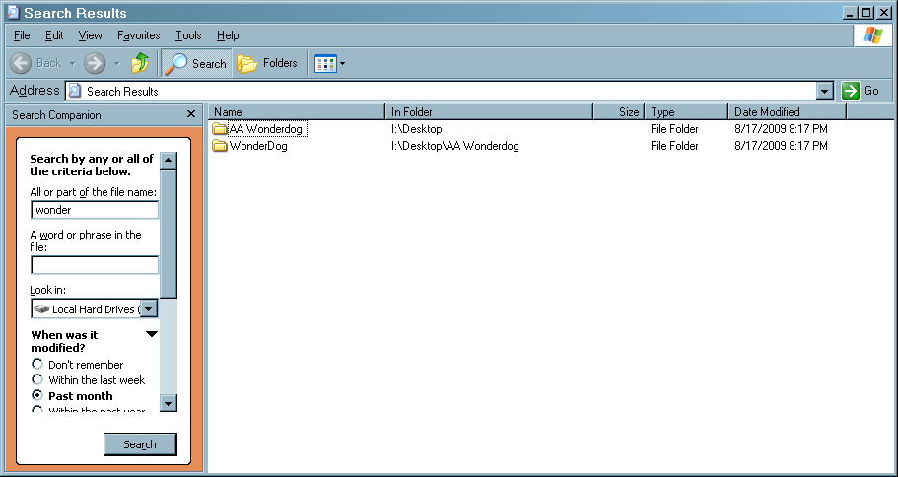

Managing Mac Files

Before we begin looking at Mac files and storage, keep this great tip in mind:

You can always receive more information and help, on any Mac related topic, by going to your menu bar at the top of the screen and selecting HELP as shown below:


1. Introducing- the DOCK
The DOCK is a major navigation tool for Macintosh users. It is used to open applications, documents, folders, servers, Web sites, QuickTime TV channels, and more. There are many ways to customize your DOCK for easy access to those applications you use the most.

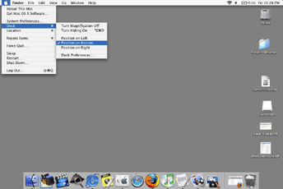

Your Desktop with the DOCK positioned at the bottom of the page

1a. To setup your DOCK preferences:
- Select Apple Icon (top right of your page)
- Select Dock
- Select Dock Preferences

1b. To open an item in the Dock:
- Click its icon.
- To open a document using an application in the Dock, drag and drop the document icon
  - to the application icon in the Dock.
- Always check to see if Right Click provides additional options for your program

2. Locating Files

There are many ways to locate files on the Mac. Here are a few to get you started:

2a. Using the FINDER
- From the DOCK, select FINDER (the icon will be the first on the left)
- Clicking on the FINDER icon will bring up the following screen:
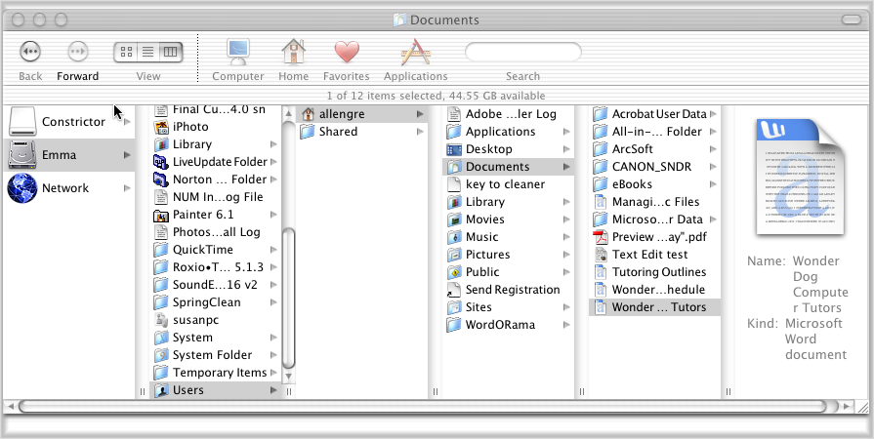

View

View Options

2b. Select how the files are displayed
- Use the menu bar (circled at the top) to select various ways to view your files
- In the example above, I have chosen the view that will step you through the location of your files
- Starting at the left with the hard drive “Emma” we have:
- Emma→Users→allengre(a user)→Documents→Wonder Dog Computer Tutors

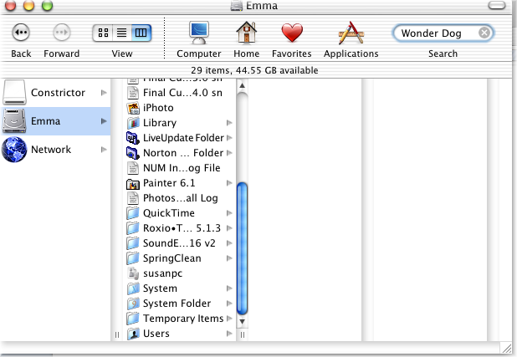
2c. Using the SEARCH Field available on most screens:

If the search Field is not visible, a useful keyboard command is: CMD F (⌘-F) for “Find”. This can be used at any time, while you are using any application.

2d. Use the FIND command
- From the file menu, select FILE→FIND
- Or, use the keyboard command: CMD F (⌘-F)

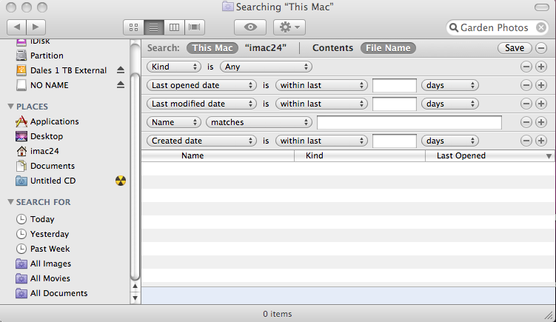
Search Options

3, Organizing Files

The best way to keep your files organized is to create a NEW FOLDER, give it a name that will help you recall it’s contents (e.g. “Flower Garden Pictures”) and place that folder in a location that makes sense.

3a. To create a New Folder:
- Go to File menu
- New Folder
- A new, untitled folder will appear
- Give this folder a new name
- Drag and Drop your folder to its new location

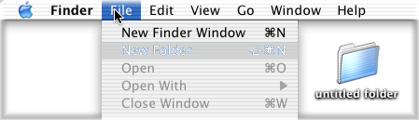

Rename Folder to “Garden Photos”

3b. To Relocate a folder:
- Drag & Drop to its new location

3c. To locate that folder/file again
- Try opening the hard drive and navigating to the appropriate location
- Select FIND from the FILE menu

