TOPIC I: Email Tips

1. The Screen

Different Screens with different email programs
- Columns and column headings
- Delete email - the X or the word delete

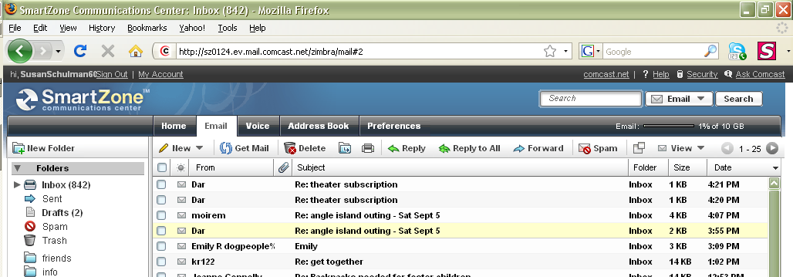

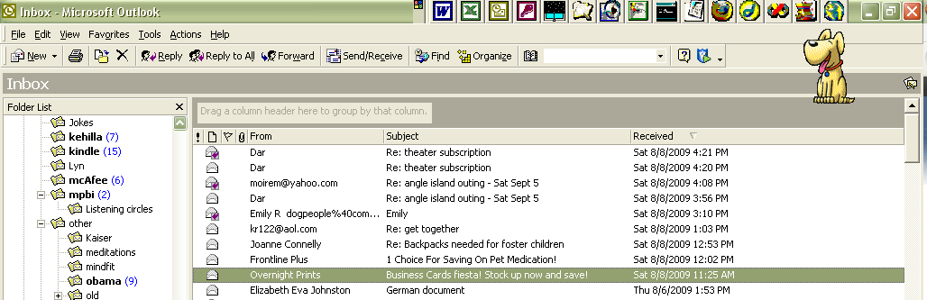
2. New Email

- To: Who are you sending the email to

- click on the word ‘To’ and select the email address you want
or
- type in the name (auto fill)

- CC and BCC
- Subject

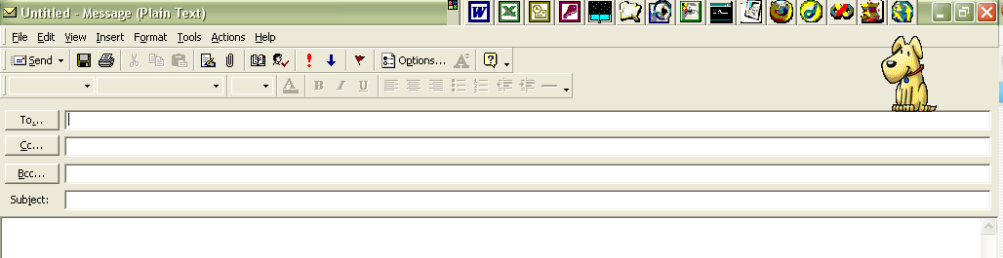

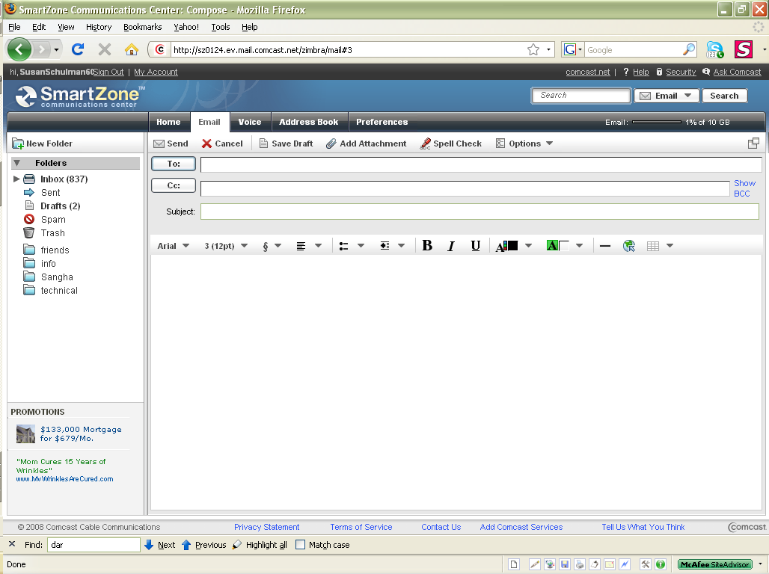

3. To view an attachments (pictures or documents)

- A paper clip usually means there is an attachment
- View the email (by clicking on it (once or twice))
- Somewhere on the email there will be a place to click to see the attachment.
(sometimes at the bottom, often in a different color)
- Click on the attachment and it should open up.

4. To keep a copy of the attachment

- If you want to keep a copy of it go to File->Save as
- Navigate to the folder you want to save it in, give it a name and press OK

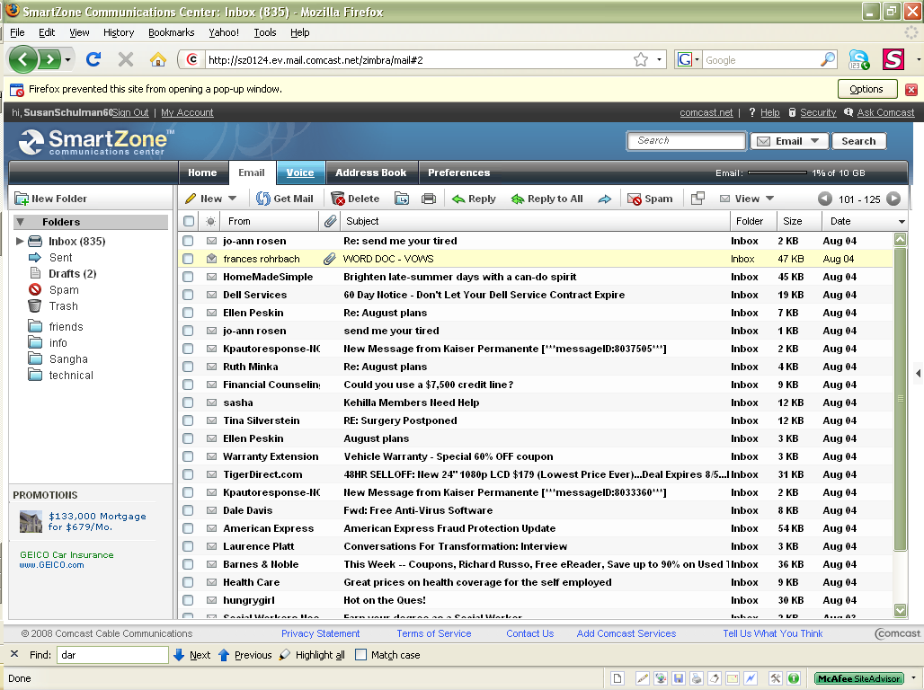

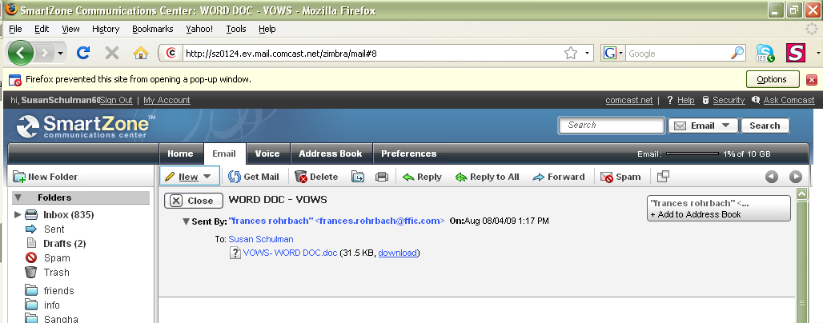

5. To create an attachment:

  - On the tool bar, click on the paper clip .
  - It will ask you to go to the folder and click on the file that you want to attach.
  - Click on OK

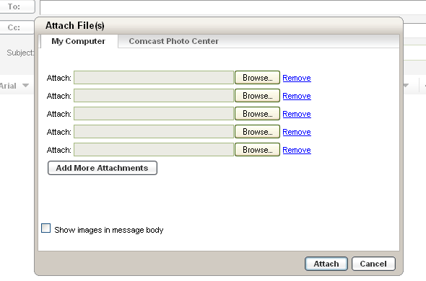

6. Folders

a. Some common folders

The Inbox Folder The Sent Folder The Outbox folder The Draft Folder The Trash (or Delete )Folder

- Make a new folder (comcast.net)

  - Click on the folder you want the new folder to be in
  - Click on New folder
  - Type in the name
  - Click on OK

- Make a new folder (outlook )

  - Right click on the folder you want the new folder to be in
  - Click on New folder
  - Type in the name
  - Click on OK
