TOPIC I: Desktop Tips and Tricks

1. Where Oh Where Has My File Gone?

One of the most frustrating problems with a computer is often trying to find that file or application you know you were working on yesterday. Let’s go to the desktop and do a search.

- Open the Start Menu (lower left corner of your screen)
- At the bottom of the window, type in any part of the file name that you can remember
- You may use * as a wildcard to represent unknown letters
- The system will bring up all files that contain the characters you type
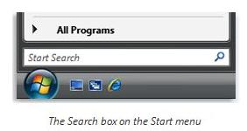
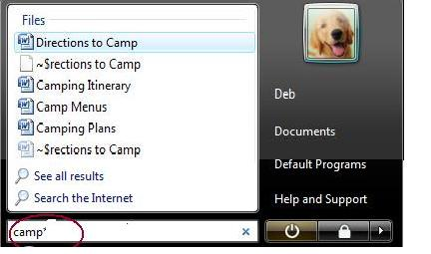

2. Creating a Shortcut
The Desktop can be a handy location for quickly accessing the applications or files you use most often. Here is an easy way to create a “shortcut” to get to those files
.
- Open the location that contains the item to which you want to create a shortcut.
- Right-click the item, and then click Create Shortcut. The new shortcut appears in the same location as the original item.
- Drag the new shortcut to the desired location.
Or:
- From any file/program list, click and drag the original item to the desktop.
- Release the mouse and a new shortcut has been created.

2. Creating a Shortcut (continued)

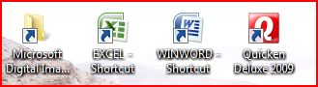
I have placed these shortcuts on my desktop. Notice the arrow indicating that this is just a “shortcut”, not the application or file itself. Note: You can create, move, delete, or rename a shortcut without affecting the original file at all!

3. Creating a New Folder
The easiest way to organize your work is to create folders that have meaning for you. Choose names that you will easily remember!

- Right click anywhere on the Desktop
- Go to “New”
- Select “Folder”
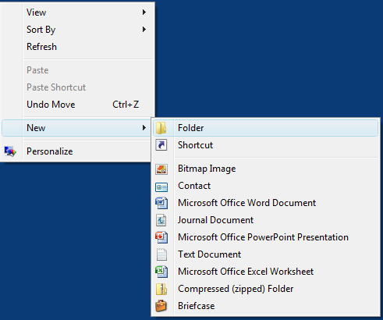
- Type new name for your folder

4. Moving A Folder
Now that you have a new folder, decide on a logical place to put it. Does it contain documents? Pictures? Videos?

- Open your Start Screen
- Select one of the Documents, Pictures, Music, or Games sections
- Click and Drag your New Folder to the location of your choice

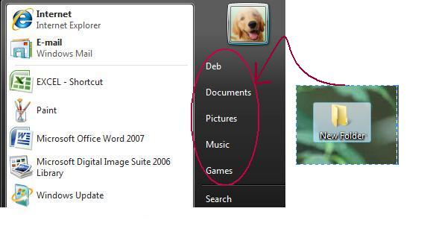

5. Back to the Desktop
Now that you have new folders and shortcuts, it’s time to organize the desktop so that you can find things easily.

- Right click on the desktop
- Select “Arrange Icons” or “Sort By” (depending on your operating system)
- Select any one of the options available
- If you would like to be able to MANUALLY arrange the icons on your desktop, be sure that you uncheck the “Auto Arrange” option available under the View menu
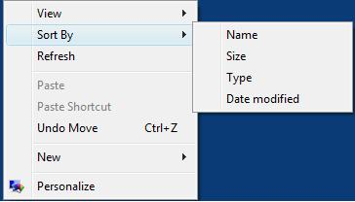

TOPIC II: Google Tips

1. Exploring the Google Search Page

- Title Bar
- Menu bar
- Google Menus
- Sign in

Different kinds of results
Search Box

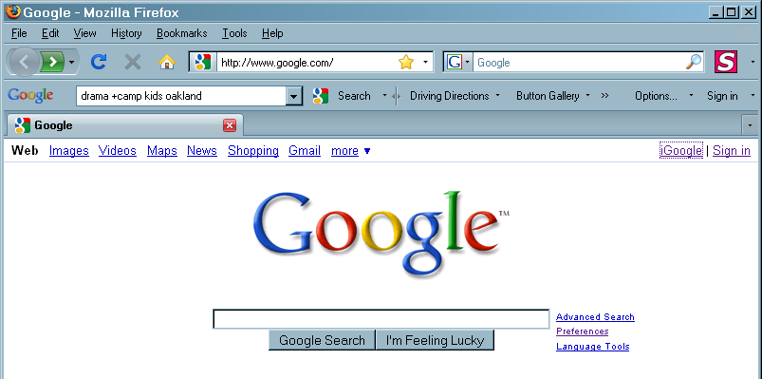
Set Preferences

Search
Box

2. Google Tool Bar

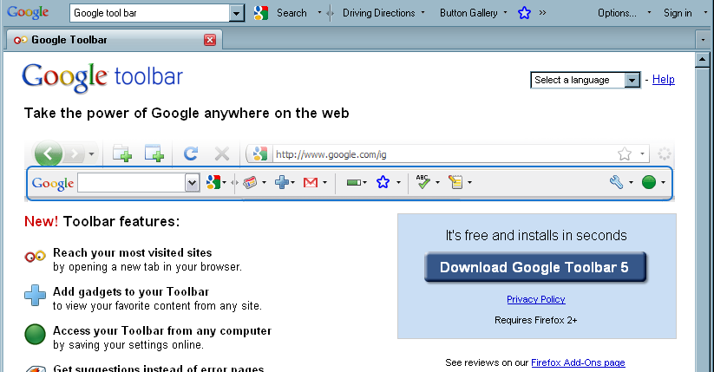
Makes Google features easier to use, almost automatically

a. More ways to look at Google results

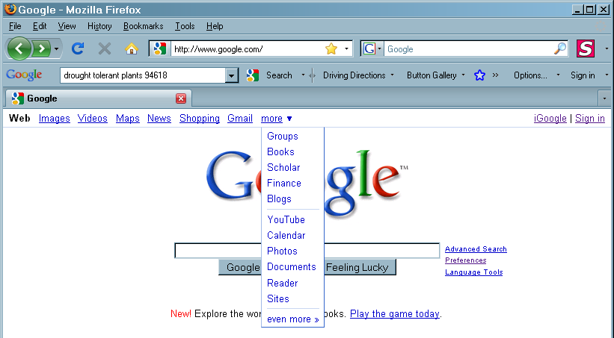
Click on MORE to find You Tube, books, photo management, etc
Click on EVEN MORE for….even more

3. Find something easily on a crowded web page.

- Click on Edit → Find (or just Ctrl F (PC) or Command F (Mac))
- In the dialog box that opens (the box may be anywhere on the screen or in the bottom status bar) type the word you want to find on the page.
- Google will highlight the word.
- Click on Next to find the next occurrence of the word in the article.
The Find box
Google highlights the word searched for

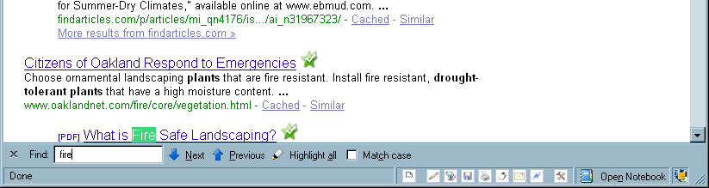

4. Look up business phone numbers.

- In the search box, type in words describing the business and the location or zip of that business

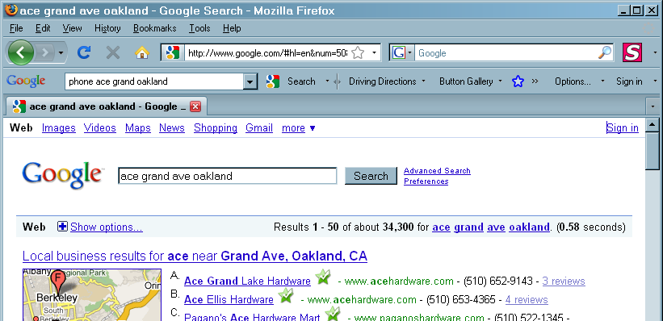

5. To make Print Bigger on the Web (in Google too)

- Find the ‘+’ key on your keyboard (near the Backspace or on the number pad near #9)
- Hold CTRL (PC) or Command (Mac) and press the ‘+’ key. Every time you press the ‘+’ key the print gets BIGGER and BIGGER.
- To make it smaller hold CTRL (PC) or Command (Mac) and press the ‘-’ key.

6. You don’t need to type very much information for Google to find stuff. Often you can find what you need with just three words.

For example type: Dr Mann Oakland
instead of: Doctor Roger A Mann, Oakland.

7. Use the ‘+’

If you type a ‘+’ before a word in the search box it will only show results that have that word in it.

For example: type Roger Mann +MD

Without the ‘+’ you might have gotten Roger Mann a chemistry teacher in Philadelphia or Roger Mann Sternfield’s Facebook Page.

8. Type the most uncommon word first

Type Elephant Sale Oakland
Instead of: Oakland Museum White Elephant Sale

Type: Baseball schedule UCSD
Instead of: University of California San Diego Schedule for Baseball 2009

9. Fill In Forms Quickly

If filling in forms is frustrating, try this. When you get to STATE in any form, just hit the letter C. California is first on the list and will fill-in automatically on most web sites. Try typing just the first letter or number you want in each box. Many websites will fill this in automatically for you. To learn more about auto-fill visit this link http://www.google.com/support/toolbar/bin/answer.py?hl=en&answer=47972.

10. Create a Bookmarks or Favorites

Go to a page you use often

Click on the Bookmarks or the Favorite menu choice (or Control D/Command D).
- Click on Bookmark This Page or Add To Favorites. A dialog box will appear containing the computers
name for the page.
- You may enter your own name for this page in the small box labeled Name: (see Figure 10.1 and 10.2 below)
- Press ENTER.

11. To find your bookmark

- Click on Bookmarks or Favorites-
- If you don’t see your Bookmark/Favorite look for arrows at top or bottom of the list. Click on these arrows to view the rest of the bookmarks/favorites.
- Click on your bookmark and the web page will open

Figure 10.1
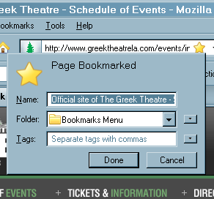
Your name for the bookmark
How the computer named the bookmark

Figure 10.2
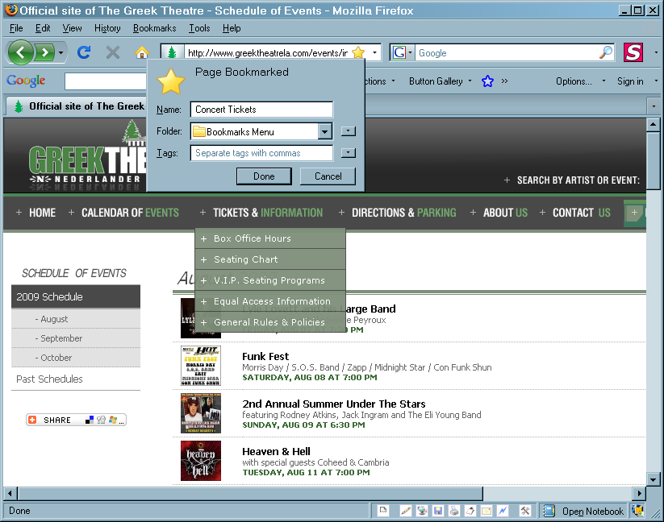

TOPIC III: Microsoft Word Tips

1. The Screen

- Title Bar
- Menu bar
- Toolbars – Standard, Formatting
- Ruler
- Status bar – page, sec, page showing / # pages in document, position insertion pt in inches, position insertion pt in line and column.
- Resting the cursor on an icon will show its meaning.
Title Bar

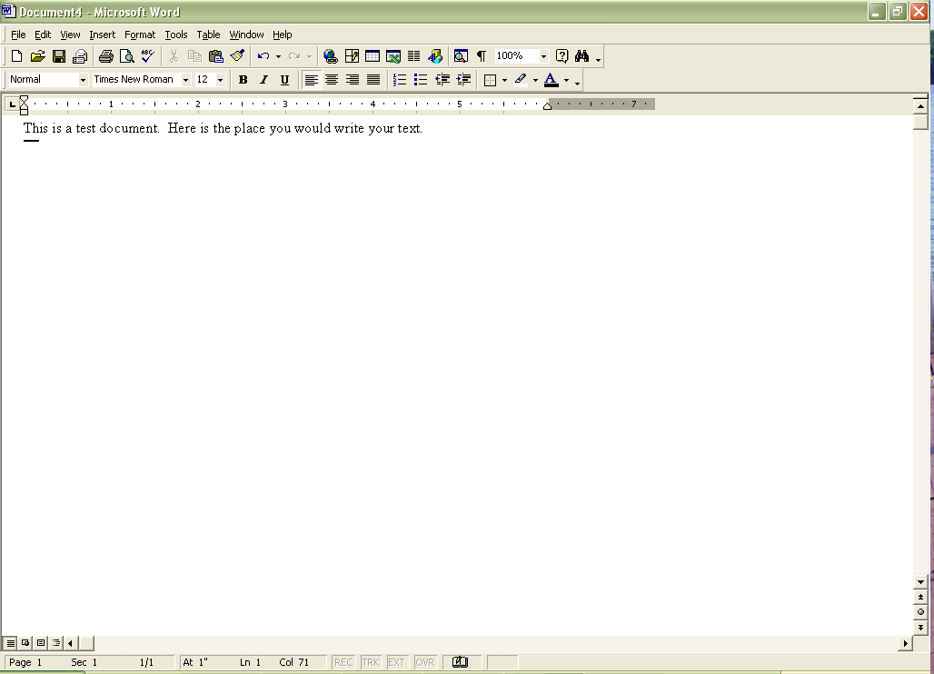
Menu Bar
Standard Toolbar
Formatting Toolbar

View Buttons
Status Bar

2. Preview a document before printing
- To display each page as it will look when printed, click Print Preview on Standard toolbar.
- To exit print preview and return to the previous
3. Undo Command (very handy!!!!!!)

- Click on Edit → Undo or click on the undo arrow on the Standard toolbar.

4. Canceling a Command or Closing a Box

- Press the ESC key.

5. Selecting Text The Easy Way

- Click at beginning of the word, phrase, sentence, paragraph or any text that you want to select.
- Hold down the shift key and click at the end of the text to be selected.
OR
- Hold down the shift key and use arrow keys to move the cursor to the end of the text to be selected

6. Having selected text you can do any of the following:

a. Change font and/or font size of the text

- Select the text you want to make change the font or font size of. (see number 5 above)
- Click the down arrow next to the font name size 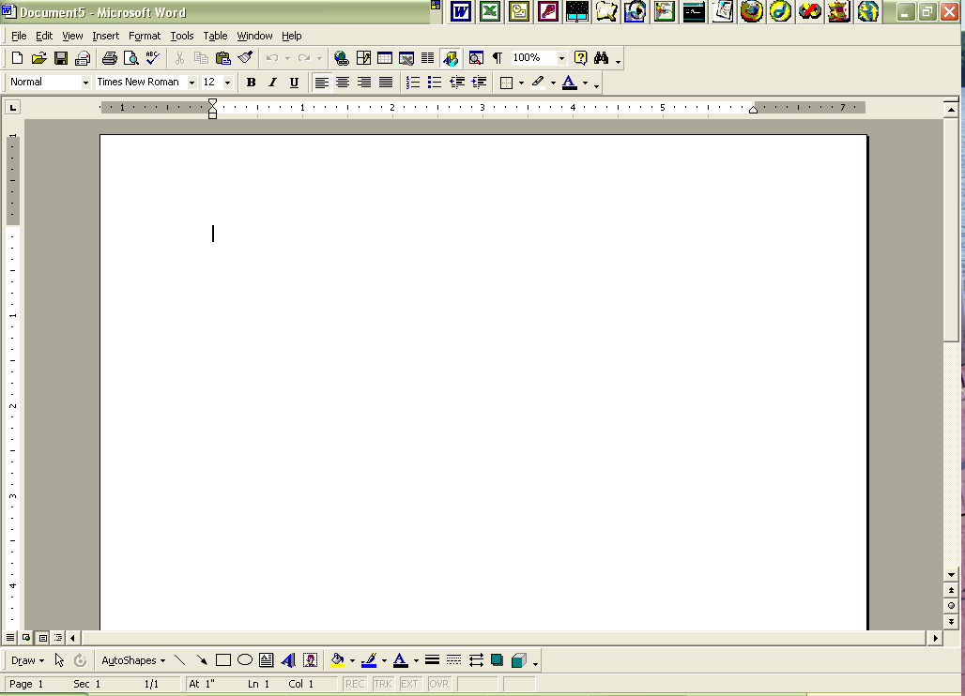 on the formatting toolbar.
- Click on the font or font size that you want to use.
- Unselect the text by clicking anywhere else in your document

b. Change color of the text

- Select the text you want to change the color of. (see number 5 above)

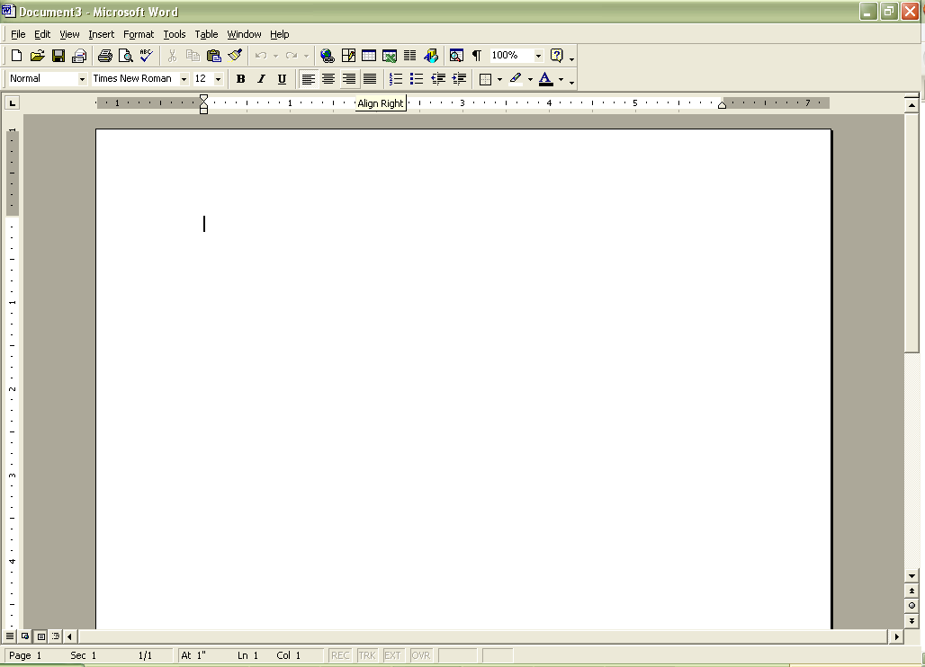
Click on the down arrow next to the capitol A on the formatting toolbar.

- Click on the color that you want the text to be.
- Unselect the text by clicking anywhere else in your document

c. Make text bold, italic or underlined

- Select the text you want to make bold, italic or underlined. (see number 5 above)
- Click on the B, the I or the U button on the formatting toolbar.

- Unselect the text by clicking anywhere else in your document
To make text not bold, not underlined or not italic use step i, ii and iii above.

7. Spell Check

- Select the text you want to spell check. (see number 5 above)
- Click the spell check icon on the formatting toolbar.

8. More Tips on Spell Check:

- Often if you RIGHT click on a misspelled word, WORD will show choices for correct spelling.
- If you want to check the whole document you do not need to select anything.

9. Cut, Copy and Paste

a. Definitions:

- Clipboard: A place that can hold text that you ask it to hold
- Cut: The text you cut is gone from where you cut it and on the clipboard
- Copy: The text you copy stays where it was and is also on the clipboard
- Paste: Puts the text that is on the clipboard where your cursor is

b. To Cut or Copy and Paste

- Select the text you want to cut or copy. (see number A above)
- Click Edit → Cut (or Copy). The text is now on the clipboard.
- Move the cursor to where you want to paste the text and CLICK ON THAT SPOT.
- Click Edit → Paste.

10. More Tips on Cut, Copy and Paste:

- Often if you RIGHT click on the selected text, WORD will show a choice to copy, cut or paste.
- Cut, Copy and Paste buttons on the standard toolbar: 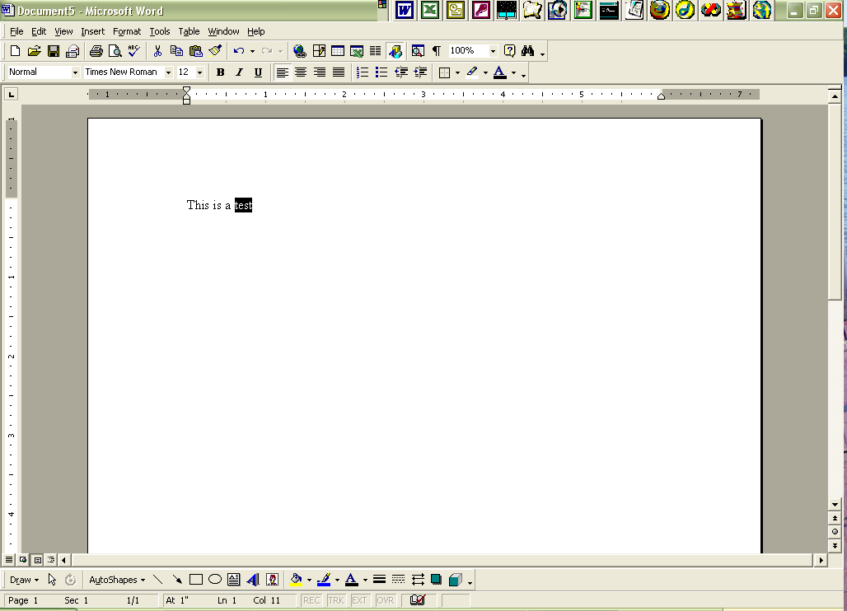

WARNING: If anything is selected and you paste,
Cut Copy Paste
the selected text will go away.

11. Setting Margins

- Click on File → Page Setup.
- Click on the Margin tab and change the margins to whatever you want them to be.
- Click on OK.

12. Inserting Art into a Document

- Click on Insert → Picture.
- A menu will open up. Click on clipart.
- Click on the category that you want and the picture that you want.
- A menu will open up. To see choices you must rest the cursor on each icon. Click on insert.

13. Sizing The Art

- When you insert your art it may be way too big.
- Click on the art. Small black boxes appear around the art.
- Click on the black box in the lower left corner and drag the box to the upper right.

14. Displaying a Toolbar

- To turn a toolbar on or off, click on View → Toolbars.
- Click on the toolbar name.
- A check mark will appear to the left of the toolbar names and the toolbar will be displayed.
- To hide the toolbar repeat steps 1 and 2.

15. Office Assistant and Help

a. Hide/ Show the office assistant:
- Click on Help → Hide or show office assistant

b. To get help
- Click on office assistant or Help→ Microsoft Word Help or press F1 key
- Type a word or question into the box. For example you may type the word “TABS” or a specific question like “How do I set tabs” (do not type the quotes)

